Identification of an Unknown – “A”
Hailey Lushington
11/28/23
Chem 2081 001

Introduction
The purpose of this experiment is to identify a specific organic compound using NMR (nuclear magnetic resonance), GCMS (Gas chromatography–mass spectrometry), and FTIR (Fourier Transform Infrared Spectroscopy) (1). All of these three analyses reveal something specific about the compound trying to be identified. All three of these together reveal vital information that all together can show the identity of the compound. The graphs provided can be used to show structure and properties of the organic compound. Both GCMS and FTIR are types of absorption spectroscopy. GCMS is the combination of gas chromatography and mass spectroscopy. FTRI method uses infrared light to test different samples and see different chemical properties.Whereas NMR is used to find radio frequency radiation in a magnetic field.
These three are used in the analysis of chemical compounds. This analysis can be broken down into two different categories. Classical analysis and instrumental analysis, as it sounds, classical analysis does not use any electronic instruments and instrumental analysis uses electronic instruments. These three methods NMR, GCMS, and FTIR are considered to be instrumental analysis. Instrumental analysis is necessary for the development of new pharmaceutical drugs vital to the continuation of human health (2). Pharmaceutical companies use a variety of instrumental analyses such as spectroscopy.
Body
NMR, nuclear magnetic resonance spectroscopy, uses a magnet to spin the nuclei of an atom (3). NMR uses radio frequency waves to promote resonance between compounds. This is the most common technique used to determine the structure of an organic compound. NMR allows scientists to find the exact connectivity and placement of different atoms. NMR spectroscopy needs a large magnetic field, this magnetic field is made from the passing of electrons through a loop. The NMR is applied to any nucleus that has a nuclear spin, and this nucleus would be similar to a small magnet. The nucleus would emit a positive charge. Radio frequency comes into play because the compound used is exposed to a little bit of radiation to cover the radio frequency range. This process excites the compound’s protons into their higher energy state and eventually the protons come back down to their initial spin states (1). A process known as free induction decay, FID, occurs when the spun nucleus slowly goes back to its original spin state that lines up with the magnetic field. NMR has many different types, the most common used is known as the ¹H proton, or proton NMR. The proton NMR has a spectrum ranging from 1-10 and the x-axis is measured in parts per million (ppm). In this spectrum peaks are the chemical shifts which are indicated by the symbol δ (4). The standard of this is tetramethylsilane (TMS) and is found at the point zero (4). TMS is used as the standard for this technique because its 12 protons have strong resonance and can have a chemical shift at lower frequencies. If a peak is closer to TMS, the peak is considered a deshielded proton. These peaks, a type of Hydrogen and equivalent hydrogens will cause one peak. Equivalent hydrogens means that if there is a change of Hydrogen position that the chemical structure will not be affected. Once the spectrum is made, it will show many properties of the compound that will help in determination such as location of signals, number of signal/s, shape of the signals, and what is under each signal. The NMR will signal from something known as an oscillating curve. This signal from the oscillating curve is converted to the original spectrum by using a Fourier Transform (1). For this spectrum to be made, the unknown compound is placed in a solvent that dissolves it. This is then put into a type of glass tube that is very narrow and then placed into the NMR spectrometer for reading.
GCMS, Gas chromatography–mass spectrometry, is a type of mass spectrometry which looks at the interaction between some matter and a type of energy source (5). This chromatography is normally used to measure the oxidation of an amino acid. Its process combines chromatography, separation of molecules components, and spectrometry, the detection of peaks. The GCMS, in lay terms, basically measures a compound's mass spectrum (mass charge ratio). It reveals information such as the mass of an ion, molecular weight, and the compound formula which are vital to discover the identity of the compound. GCMS works firstly by getting a sample of the compound in its gaseous phase. During this gas phase, its molecules are then, for lack of a better word, shot with an electron beam with the average beam being 70 electron volts (1). This is enough energy to cause an electron of the compound to leave and change into something called a radical cation. A radical cation is when an unpaired electron and a cation are together and lose an electron (i.e. change it to a positively charged ion). The process just described is known as electron impact ionization (1) and these charged ions are then deflected by a magnetic field. Because the ion is considered unstable it will disperse into very small pieces which lets GCMS find its charge to mass ratio discussed earlier. This magnetic field is also vital because ions have different masses and this allows the magnetic field to deflect them at differential angles (1). The different angles let the GCMS analyze the compound's structure and show it on a spectrum. This spectrum is plotted based on mass and charge against its relative abundance in the compound, it is shown based on peaks and the highest peak for GCMS is known as a base peak. The base peak is considered to have the most abundance. This peak is also given a value of 100%. It’s measured at 100% so that all other peaks shown in the spectrum can be compared to the most abundant peak. GCMS also measures the distance between all peaks shown on the spectrum. These are measured because their distance will designate a molecule therefore narrowing the compound's identity down. The smaller peaks are normally dictated to be isotope peaks and are very minute when you compare them to the base peaks (1).
Finally, FTIR, Fourier Transform Infrared Spectroscopy, measures the spectroscopy of a given compound. FTIR is a type of algorithm that converts all the information given by a detector and makes it into a spectrum. Spectroscopy gives all the information regarding a compound's structure and the spectrum used in FTIR gets all its information at one time. The FTIR finds the interactions between a compound’s molecules using electromagnetic energy at a variety of wavelengths (1). For this electromagnetic energy, light is used to test the sample. Light is shined into a sample at differential intensities because many factors of a compound react differently depending on a light's intensity. These factors could include functional groups present and varying parts of a molecule because of bond strengths and atomic mass (1). For organic molecules, light absorption excites some of the molecules and causes different kinds of vibrations. Molecular vibration can occur in varying ways, one example is if a compound is say a tetrahedron it can vibrate multiple different ways. A tetrahedron can have in-plane or out-of-plane bending and stretching can occur (1). These different vibrations show different absorption patterns that show a multitude of information about a given compound. For the FTIR spectrum, the wavelengths of a given organic compound range from 2.5 X 10⁻⁴ cm all the way to 2.5 X 10⁻³ cm (1). Though this is given in wavelengths, signals are recorded in something called wavenumbers which are simply the reciprocal of a wavelength (1). So for the FTIR the wavenumber range is as follows, 4,000 cm to 400 cm. FTIR’s spectrum can be in two different types of terms absorbance, the less used, or transmission, the more commonly used. The spectrum part between 1500 cm to 400 cm is known as the fingerprint region (1). This can be thought of like a human fingerprint, all human fingerprints have unique characteristics and no one’s fingerprint is the same. The same applies for an organic compound. The specific peaks are completely unique to a certain compound which allows FTIR to give the identity of a compound. The signals found in a spectrum can be determined as narrow, broad, strong, medium, or weak. Though FTIR seems like it could show the characteristics for a specific compound, it is most commonly used to find the characteristics of a function group. FTIR combined with both NMR and GCMS make it possible to find the specific unknown compound.
Data
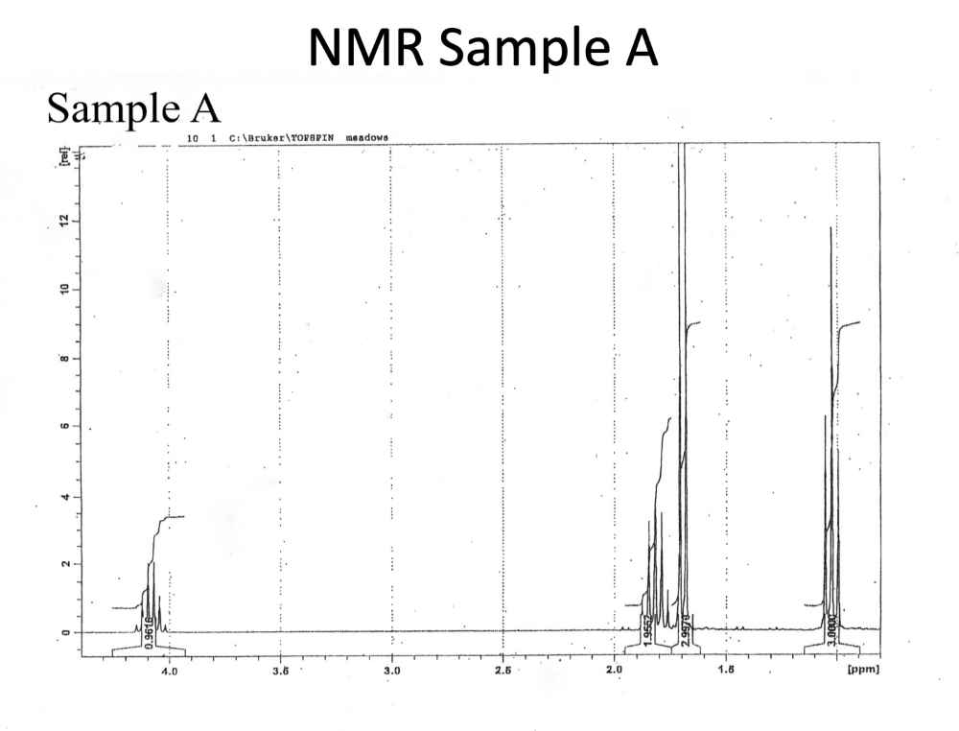
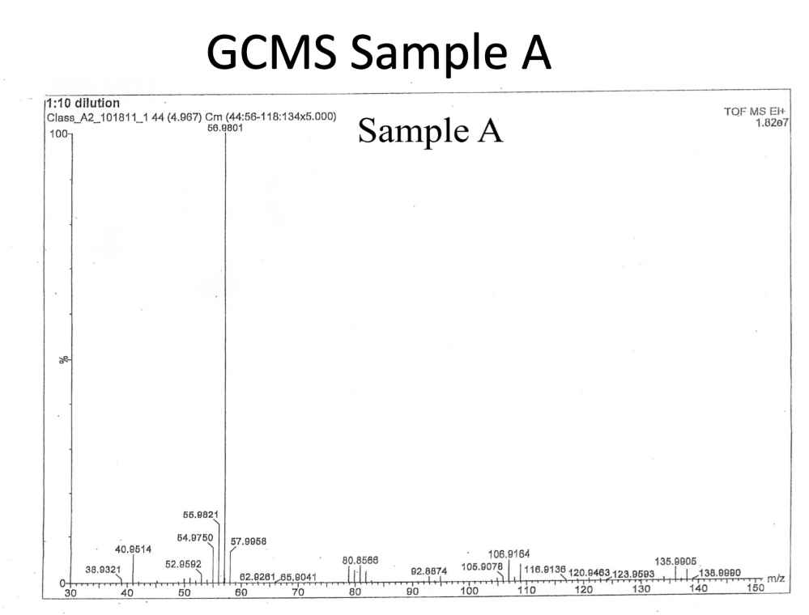
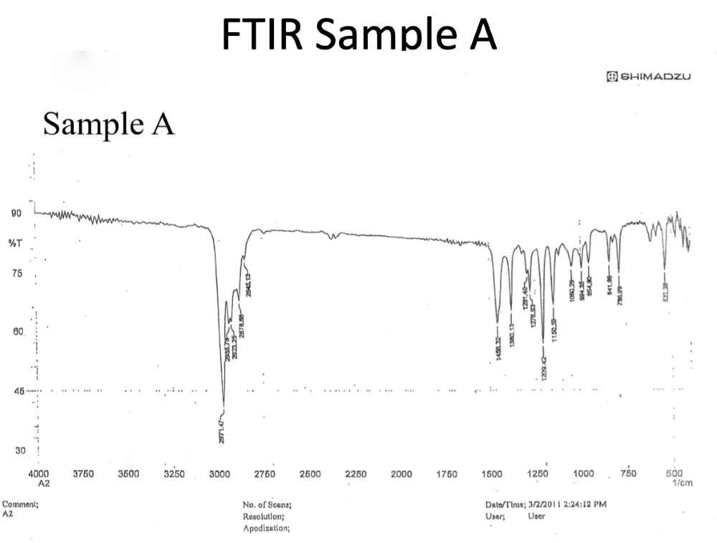
Analysis
For the first spectrum, NMR, going from the left to the right the ratio of the signal is 1:2:3:3. The signal peak furthest to the left shows that there is only one proton, the signal at 1.8 ppm shows two protons, and the signal at 1.7 ppm and 1.0 ppm give 3 protons each. Indicating the given compound has 9 protons. The signal at 4.1 ppm can be assumed that it is a deshielded proton and this could be a Carbon connected a Halogen group or an Oxygen such as HC-X- or even -HC-O-. Also, the proton at 4.1 ppm indicates an isolated proton and that its multiplicity as a sextet, the proton has five coupled protons neighboring it. Protons at both 1.7 ppm and 1.0 ppm show methyl groups. However, the methyl group at 1.7 ppm seems to be connected to a Carbon atom that is near a type of electronegative atom. This atom deshields the protons. The 1.8 ppm signal should go with a methylene group because of the two protons.
The GCMS spectrum is more complicated because of the three peaks. However, looking at the pattern of peaks from 136 and 138, they have a ratio of 1: 0.98. This pattern corresponds with Bromine atoms. The most abundant isotopes of Bromine are as follows ⁷⁹Br and ⁸¹Br, their abundance rates of 50.5% and 49.8% once again correspond with the rise of the peak. Because of this the ion peaks at 136 m/z and that makes the molecular weight of the molecule 136 g/mol. The weight of the Br isotopes give a molecular weight of 137 g/mol. Also, at peak 57 the most stable ion is formed there. It is the most stable because based on the spectrum it is the most intense and also is at 79 m/z units. If you subtract the molecular weight from earlier, 136, minus the 79 m/z you get 57, which confirms the presence of Br.
Lastly, the FTIR spectrum signals vibrations. The vibrations show correspond to -CH₂- and -CH₃-. This is because the vibrations are located at <3000 cm⁻¹. The graph also shows two other vibration areas. The vibration area on the FTIR between 1200 cm⁻¹ and 1500 cm⁻¹ also coincides with the -CH₂- and -CH₃-. The last vibration found at 522 cm⁻¹ is found to be C-Br bond stretching. This is congruent with the finding of the GCMS presence of Br being confirmed.
Conclusion
Looking at the previous molecular weight of 137 g/mol one possibility is C₄H₉Br. There is enough evidence for this molecular formula because of GCMS and FTIR confirming the presence of a Bromine atom. It is also confirmed by the proton number of 9 given from the NMR spectrum. The NMR also lets us find the structure of the compound because it shows that there was an isolated proton near an electronegative atom, which was discovered to Bromine. Giving this general structure: H3C-CHBr-CH2-CH3. Because of all of this the compound is 2-bromobutane, the chemical formula is C₄H₉Br and the structure drawing is below.
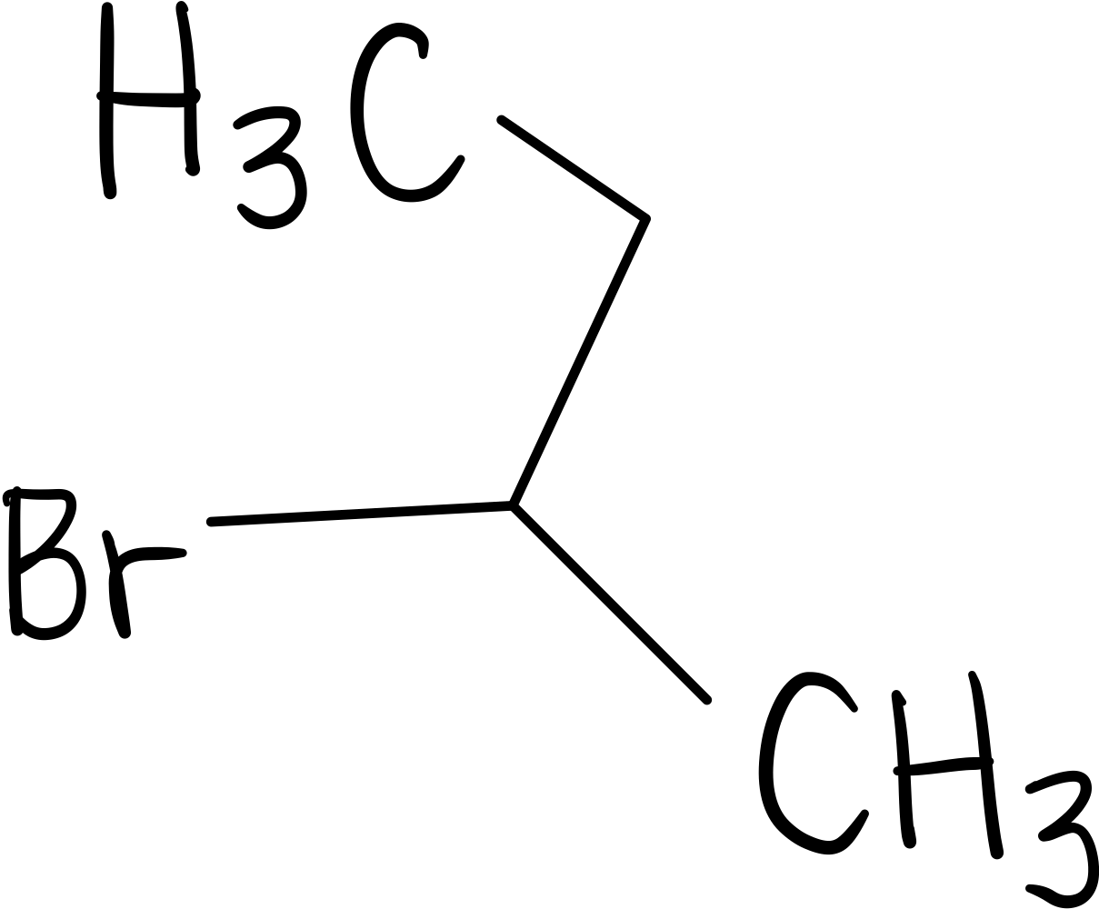
References
1. Keller L, Joseph K, and Miguel S. 2023 Fall. CHEM 2081 Organic Chemistry 2 Lab Manual [lab manual]. Auburn (Al): Auburn University.
2. Siddiqui, AlOthman, Rahman et al. “Analytical Techniques in Pharmaceutical Analysis: A Review.” Arabian Journal of Chemistry, Elsevier, 23 Apr. 2013, www.sciencedirect.com/science/article/pii/S1878535213001056.
3. “Introduction to NMR.” Chemistry LibreTexts, Libretexts, 30 Jan. 2023, chem.libretexts.org/Bookshelves/Physical_and_Theoretical_Chemistry_Textbook_Maps/Supplemental_Modules_(Physical_and_Theoretical_Chemistry)/Spectroscopy/Magnetic_Resonance_Spectroscopies/Nuclear_Magnetic_Resonance/Nuclear_Magnetic_Resonance_II.
4. “Tetramethylsilane.” American Chemical Society, www.acs.org/molecule-of-the-week/archive/t/tetramethylsilane.html. Accessed 28 Nov. 2023.
5. “Gas Chromatography Mass Spectrometry (GCMS).” Gas Chromatography Mass Spectrometry (GCMS) - an Overview | ScienceDirect Topics, www.sciencedirect.com/topics/chemistry/gas-chromatography-mass-spectrometry-gcms#:~:text=1%20Gas%20chromatography%2FMass%20spectrometry,derivatize%20samples%20prior%20to%20analysis. Accessed 28 Nov. 2023.

